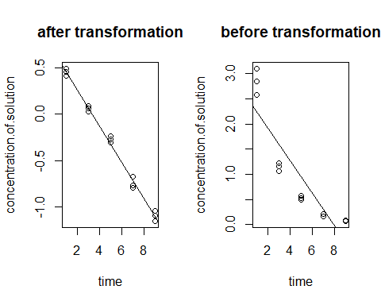

##### e. analysis the new residuals

# residual against fitted value  
plot(reg_16_c,1)

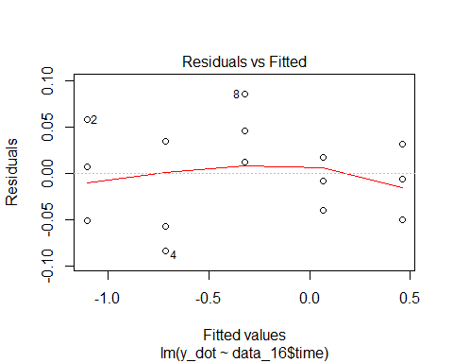

# test normality  
qqnorm(reg_16_c$residuals)  
qqline(reg_16_c$residuals)

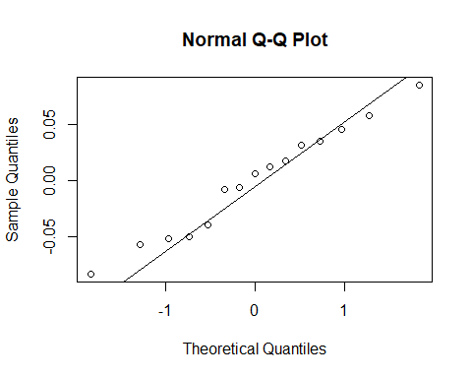

#### problem 24

##### a. estimate the orginal data

data_24 <- read.table('3.24.txt',header = FALSE, col.names = c('blood pressure','age'))  
reg_24 <- lm(data_24$blood.pressure ~ data_24$age)  
par(mfrow=c(1,2))  
plot(reg_24$residuals ~ data_24$age, main='blood pressure v.s. age',xlab='age',ylab='blood pressure')  
plot(data_24$blood.pressure ~ data_24$age)  
abline(reg_24)

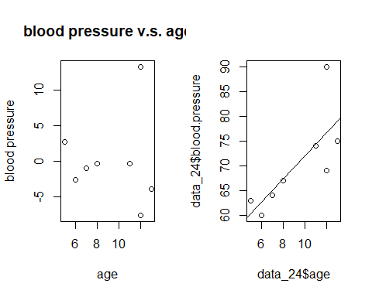

##### b. estimate after omitting one possible outlier

data_24_new <- data_24[-7,]  
reg_24_new <- lm(data_24_new$blood.pressure ~ data_24_new$age)  
par(mfrow=c(2,2))  
plot(reg_24_new$residuals ~ data_24_new$age, main='blood pressure v.s. age',xlab='age',ylab='blood pressure')  
plot(data_24_new$blood.pressure ~ data_24_new$age)  
abline(reg_24_new)  
qqnorm(data_24$blood.pressure)  
qqline(data_24$blood.pressure)  
qqnorm(data_24_new$blood.pressure)  
qqline(data_24_new$blood.pressure)

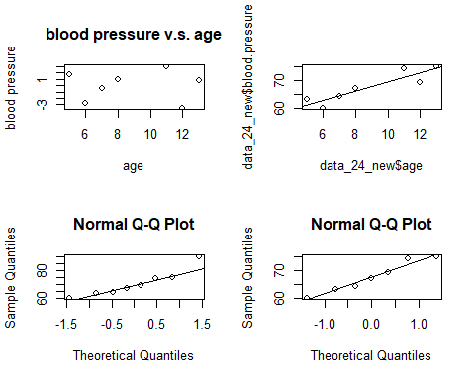

#### Problem 3.31

data_31 <- read.table('3.31.txt',header = FALSE,col.names = c('indentical number','sales prive','finished square feet','nuber of bedrooms','number of bathrooms','air conditioning','garage size','pool','year built','quality','style','lot size','adjacent of high way'))  
set.seed(1)  
# obtain a random sample  
sample_31 <- sample(500,200)  
data_31 <- data_31[sample_31,]  
reg_31 <- lm(data_31$sales.prive~data_31$finished.square.feet)  
summary(reg_31)